**Software Development Life Cycle (SDLC) :**

* **Software development life cycle (SDLC) is a structured process that is used to design, develop, and test good-quality software.**
* SDLC, or software development life cycle, is a methodology that defines the entire procedure of software development step-by-step.
* The **goal of the SDLC life cycle model** is to deliver high-quality, maintainable software that meets the user’s requirements.
* SDLC in software engineering models outlines the plan for each stage so that each stage of the software development model can perform its task efficiently to deliver the software at a low cost within a given time frame that meets users requirements.

**Diagram :**

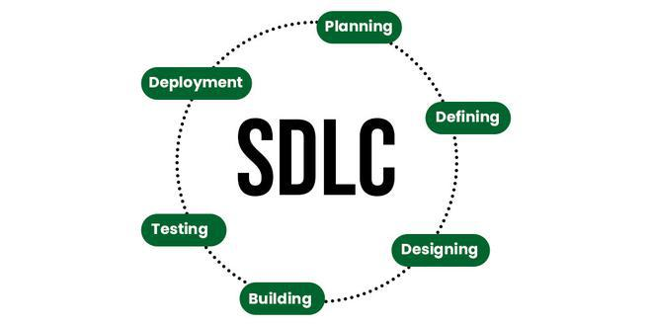

**Stages of the Software Development Life Cycle :**

**Stage-1: Planning and Requirement Analysis :**

* Planning is a crucial step in everything, just as in[software development](https://www.geeksforgeeks.org/software-development). In this same stage, [requirement analysis](https://www.geeksforgeeks.org/activities-involved-in-software-requirement-analysis)is also performed by the developers of the organization.
* Requirement analysis is the most important and fundamental stage in SDLC.
* It is performed by the senior members of the team with inputs from the customer, the sales department, market surveys and domain experts in the industry. The insights gathered serve as the foundation for the project.
* Proper planning ensures the quality of the project, and using the available information, the basic design of the project is created in this stage .

**Stage-2: Defining Requirements :**

* This stage involves specifying all the requirements for the target software, which are then reviewed and approved by customers, market analysts, and stakeholders.
* The process relies on creating a **Software Requirement Specification (SRS)** document, a comprehensive guide outlining the functional and non-functional requirements of the project.
* The SRS serves as a blueprint, detailing what needs to be developed and ensuring all stakeholders have a clear understanding of the project's scope and deliverables.
* It provides a foundation for design, development, and testing, ensuring alignment throughout the project lifecycle.

**Stage-3: Designing Architecture :**

* In this stage, software designers use the **SRS** as a reference to create the best possible architecture for the software.
* Multiple architectural designs are documented in the **Design Document Specification (DDS)**, which outlines various approaches.
* The DDS is then reviewed by market analysts and stakeholders, considering factors like risk assessment, robustness, modularity, budget, and time constraints.
* After thorough assessment, the most suitable design is selected for development, ensuring it aligns with project goals and constraints.

**Stage-4: Developing Product :**

* In this stage of SDLC the actual development starts and the product is built.
* Developers write code based on the design outlined in the **DDS**. Hence, it is important for the coders to follow the protocols set by the association.
* Conventional programming tools such as compilers, interpreters, and debuggers are utilized to ensure efficient development.
* Popular programming languages like **C/C++, Python, and Java** are chosen based on the project requirements and software regulations.
* The focus during this phase is on implementing the design accurately to build a functional product.

**Stage-5: Product Testing and Integration**

* After the development of the product, testing of the software is necessary to ensure its smooth execution.
* While minimal testing is conducted at each stage of the SDLC, this stage involves thorough testing to identify, fix, and retest any flaws.
* The goal is to ensure the product meets the quality requirements specified in the **SRS**. Additionally, **documentation**, **training**, and **support** are key aspects of this stage.
* Software documentation provides essential information about the software's processes, functions, and maintenance, acting as a reference for users and developers. It also includes user guides on how to operate the product.

**Stage-6: Deployment and Maintenance of Products :**

* After thorough testing, the final product is released in phases according to the organization’s strategy.
* It is then tested in a real industrial environment to ensure smooth performance. If the product performs well, it is fully launched.
* Feedback from users is gathered to make any necessary improvements, and the product is updated accordingly to better serve customers.

**Software Development Life Cycle Models :**

1. **Waterfall Model**: A simple, sequential model where each phase must be completed before moving to the next. It's not used much today because it’s rigid and lacks flexibility.
2. **Agile Model**: Designed for quick adaptability to changing requirements. It focuses on fast project completion . The agile model refers to a group of development processes.
3. **Iterative Model**: In this model, development is done in cycles, with each cycle producing a partially developed version. Over time, more features are added until the final product is complete.
4. **Spiral Model**: The spiral model in SDLC is one of the most crucial SDLC models that provides support for risk handling. It has various spirals in its diagrammatic representation; the number of spirals depends upon the type of project.
5. **V-Shaped Model**: Similar to the Waterfall model but with a testing phase after every development phase. Each development stage is paired with a corresponding testing stage, ensuring verification and validation.
6. **Big Bang Model**: An informal approach to software development with no specific planning or structured phases. Development starts with little to no prior planning.